Video 15 : Enhancement In Multi Threading

Thread Group :-
Based on the functionality we can grouped threads into a single unit which is nothing but thread group.
- In addition to thread group can also contain sub thread groups.
- The main advantage of maintaining threads is the form of Thread group is we can perform common operations very easily.

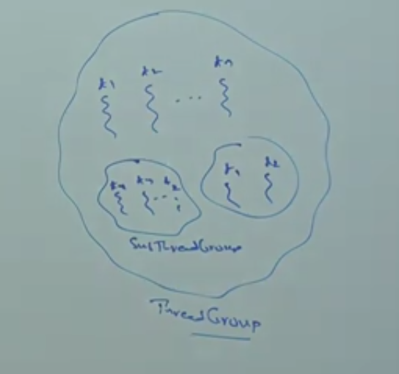

- Every thread in java belongs to some group.
- Main Thread belongs to “main” group.
- Every Thread group in java is the child group of “system” group, Either directly or indirectly. Hence system group act as root for all thread groups in java.
- system groups contains several system level threads like:
- Finalizer ( To clean up resources before an object is garbaged-collected).
- Reference Handler ( To notify the JVM when objects become eligible for GC)
- Signal Dispatcher (To allow java to respond properly to OS-Level events)
- Attatch Listener ( It lets tools attatch to the JVM for monitoring or debugging)
- ...
- ThreadGroup is a java class present in java.lang package and it is direct class of object.



program

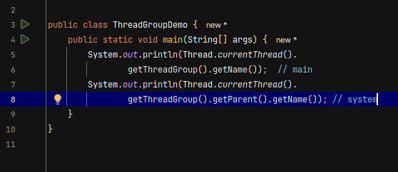

Construcotors :-
- ThreadGroup g = new ThreadGroup (String groupName)
  - creates a new ThreadGroup with specified group name.
  - The parent of this new group is the ThreadGroup of currently executing thread.
  - ex. ThreadGroup g = new ThreadGroup (“first group”);

- ThreadGroup g = new ThreadGroup (ThreadGroup m, String GroupName)
  - creates a new ThreadGroup with specified group name.
  - the parent of this new Thread group is specified parent group.
  - ex. ThreadGroup g1 = new ThreadGroup(g, “second group”)

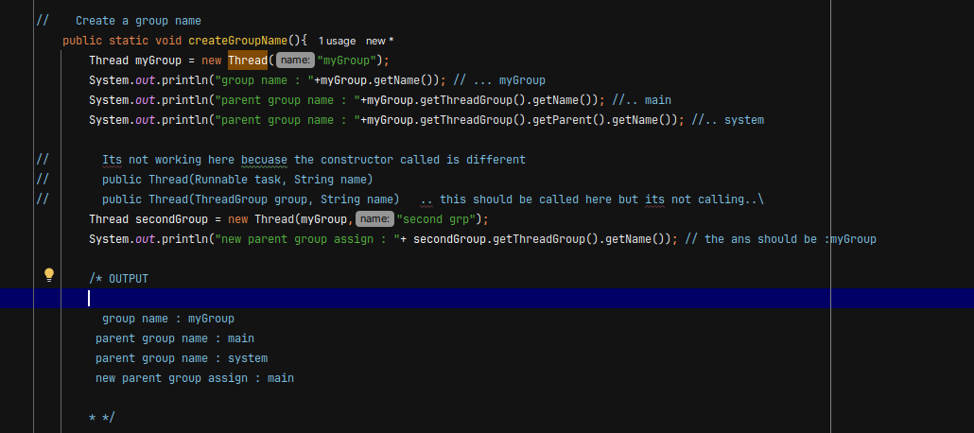

(my lines :- Correction i should have create a Different class with Thread group and Thread name constructor and called super constructor then it will able to called that constructor)
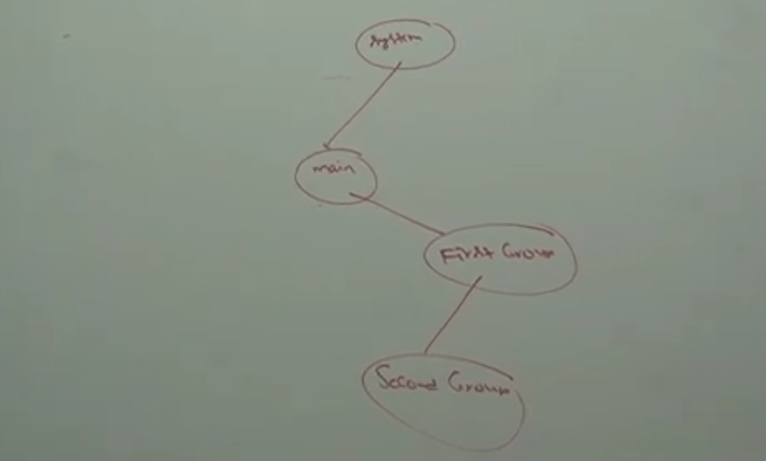

Important methods of ThreadGroup class :-

- String getName() :- returns name of the ThreadGroup.
- int getMaxPriority() :- returns max priority of ThreadGroup.
- void setMaxPriority(int p) :- to set maximum priority of ThreadGroup.
- The defualt max priority is 10
- ThreadGroup getParent() :- returns parent group of current thread.
- void list() :- It prints information about ThreadGroup to the console.
- int activeCount() :- returns number of active Threads present in the ThreadGroup.
- int activeGroupCount() :- It returns number of active groups present in the current ThreadGroup.
- int enumerate(Thread[] t) :- To copy all active Threads of this ThreadGroup into provided Thread array.
- In this case sub thread group threads will also consider.
- int enumerate(ThreadGroup [] g) :- To copy all active sub thread groups into ThreadGroup array.
- boolean isDeamon() :- To check wheather the ThreadGroup is deamon or not.
- void setDeamon(boolean b) :- To change the deamon nature of the thread group.
- void interrupt() :- To interrupt all waiting or sleeping threads present in the ThreadGroup.
- void destroy () :- To destroy ThreadGroup and its sub ThreadGroups.

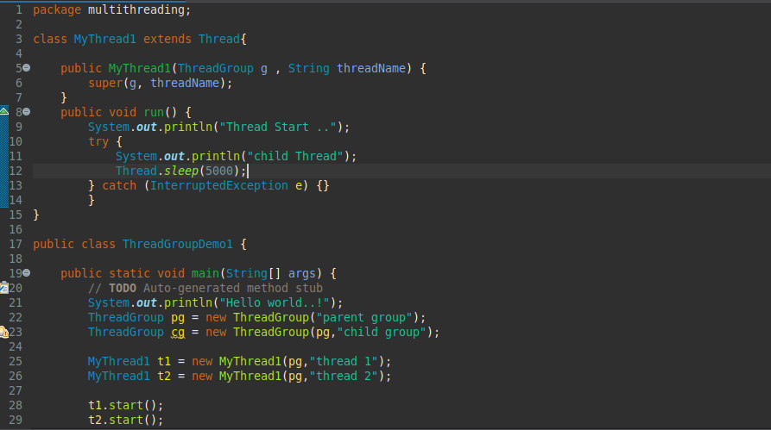

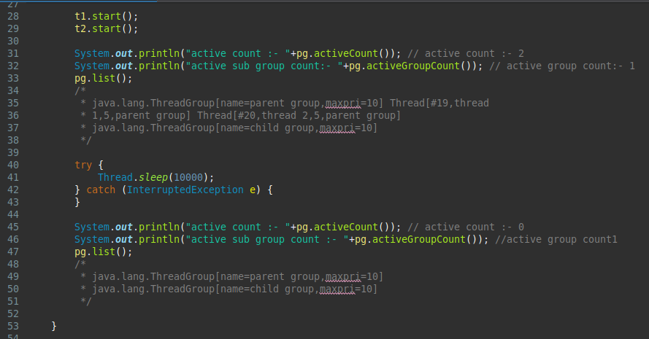

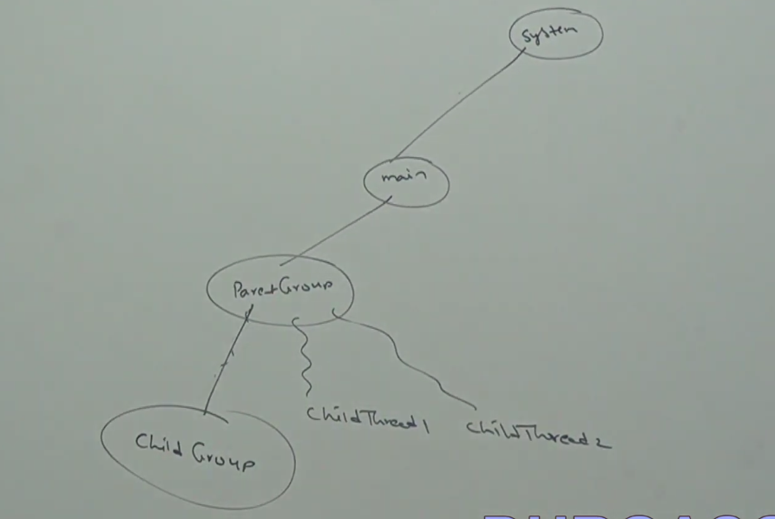

# Write a program to display all active thread names which belongs to system group and its child group

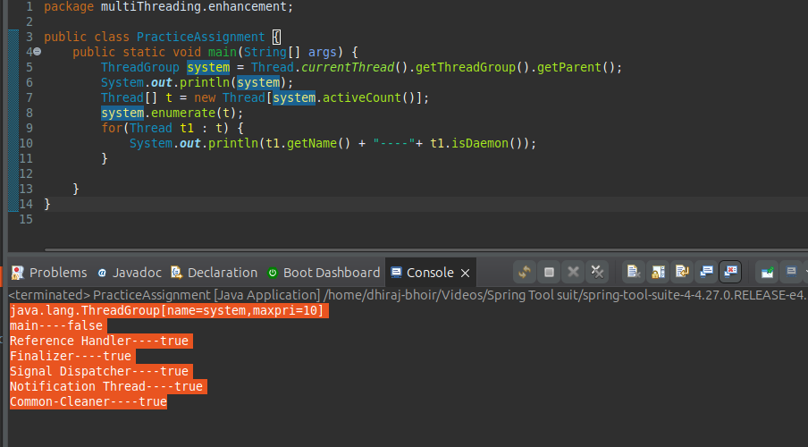

Video 16 :- java.lang.concurent.lock (version 1.5)

# The problems with traditional synchronised keyword
- We are not having any flexibility to try for a lock without waiting.
- There is no way to specify maximum waiting time for a thread to get lock, so that Thread will wait until getting a lock which may create performance problems which may cause deadlock.
- If a Thread releases a lock then which waiting Thread will get that lock we are not having any control on this.
- There is no API to list out all waiting Threads for a lock .
- The synchronized keyword compulsory we have to use either at method level or within the method and it is not possible to use across multiple methods.

To overcome this problems SUN people introduced java.util.concurrent.locks package.
It also provides several enhancements to the programmer to provide more control on concurrency.

# Lock Interface
Lock object is similar to implicit lock aquire by a Thread to execute synchronized method or synchronized block.
Lock Implimentation provides more extensive operation than traditional implicit lock.

# Important Methods of Lock Interface

- void lock() :- We can use this method to aquired a lock, If a lock already available then immediately current Thread will get lock, If the lock is not already available then it will try until getting the lock. It is the exactly same behevior of traditional synchronized keyword.
- boolean tryLock() :- To aquire the lock without waiting if the lock is available then the Threads aquire that lock and return the true, If the lock is not available then this method returns false and continue its execution without waiting, In this case Thread never will entered into the waiting state.
if( l.tryLock){
Perform safe operations.
}else{
Perform Alternative Operations.
}
- boolean tryLock( long time, TimeUnit unit) :- If the lock is available then the Thread will get the lock and continue its execution. If the lock is not available then the Thread will wait until specified amount of time still if the lock is not available then Thread can continue its execution.

# TimeUnit :- TimeUnit is an Enum present in java.lang.concurrent package.



if ( l.tryLock( 1000, TimeUnit.MILLISECONDS)){ .... }

- void lockInterruptibly() :- Aquires the lock if its available and returns immediately.
if the lock is not available then it will wait, While waiting if the Thread is interrupted then Thread won’t get the lock.
- void unlock() :- To Releases the lock.
To call this method compulsory current Thread should be owner of the lock otherwise we will get RuntimeException saying IllegalMonitorStateException.

Video 17 :- ReentrantLock

#ReentrantLock :- It is the implimentation class of Lock interface and it is the direct child class of object class.
ReentrantLock means a Thread can aquire same lock multiple times without any issue.

Internally ReentrantLock increments Threads personal count whenever we called lock() method and decrements count value whenever thread calls unloack() and lock will be realease whenever count reaches zero.

Constructors :-

- ReentrantLock l = new ReentrantLock ();
Creates an instance of ReentrantLock.
- ReentrantLock l = new ReentrantLock (boolean fairness);
Creates ReentrantLock with given fairness policy. If the fairness is true then logest waiting Thread can aquire the lock if it is available i.e it follows first come first serve policy. If fairness is false then which waiting thread will get the chance we can’t expect.
Note :- The Defualt value for fairness is false.

# Which of the following declarations are equal.
ReentrantLock l = new ReentrantLock ();
ReentrantLock l = new ReentrantLock (true);
ReentrantLock l = new ReentrantLock (false);
all the above
==> first and third ( default value - false)

# Important methods of ReentrantLock :-
- void lock()
- boolean tryLock();
- boolean tryLock(long I, TimeUnit t)
- void lockInterruptibly()
- void unlock()

- int getHoldCount() :- Returns the number of hold on this lock by current Thread.
- boolean isHeldByCurrentThread() :- Returns a true if and only if lock is hold by current thread.
- int getQueuedLength() :- Returns number of threads waiting for the lock.
- Collection getQueuedThreads() :- It returns the collection of Threads which are waiting to get a lock.
- boolean hasQueuedThreads() :- Returns a true if any Thread waiting to get the lock
- boolean isLocked() :- Returns true if the lock is aquired by same thread.
- boolean isFair() :- Return true if the fairness is set with true value.
- Thread getOwner() :- Return the thread which aquires the lock.

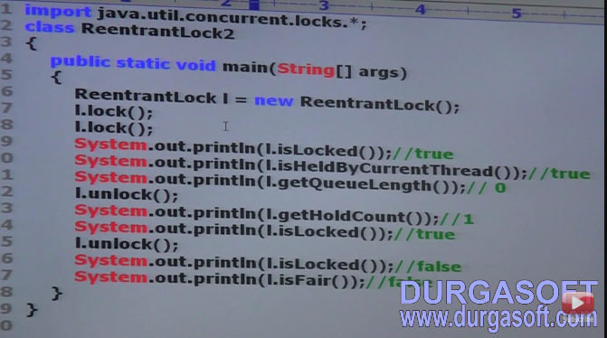

example :- Instead of synchronized keyword uses of ReenterentLock.

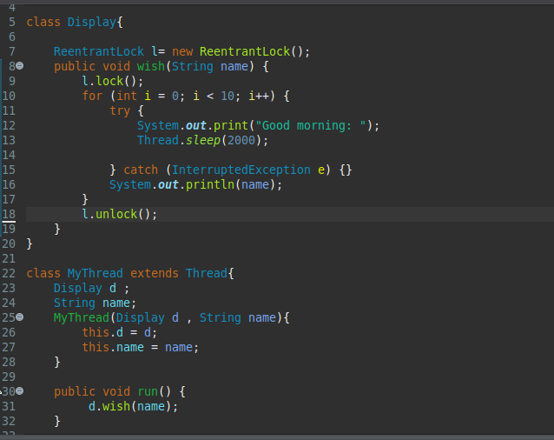

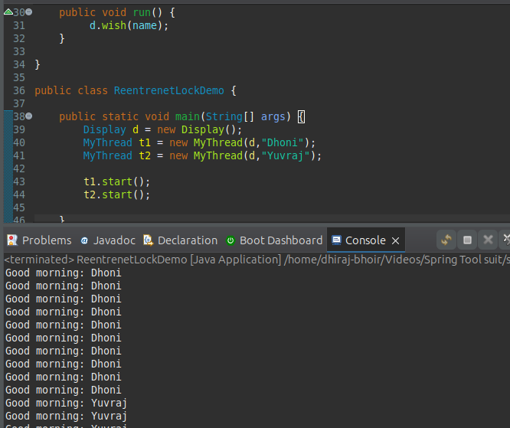

if comment line [ l.lock(); ] & [ l.unlock() ] then the threads will be executed simultaneously and we will get irregular output.
If we are not commenting this lines then Threads will be executed one by one and we will get regular output.

# Demo program for tryLock() method.

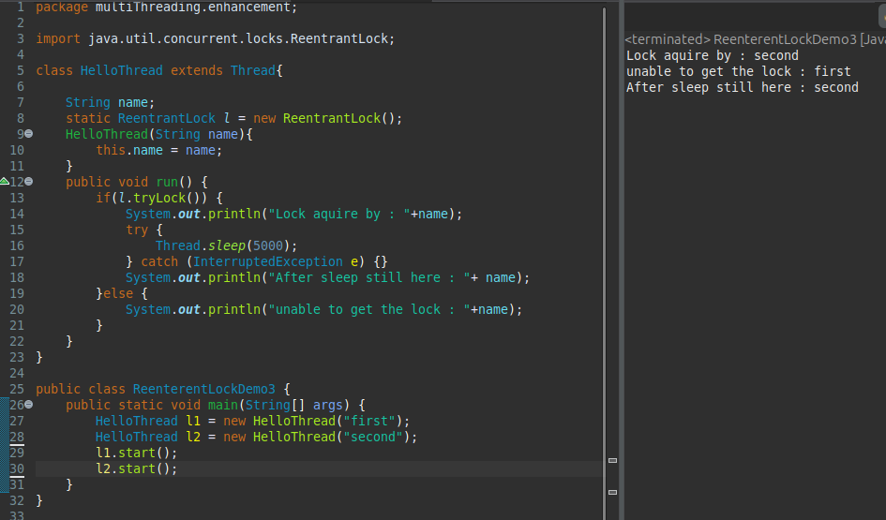

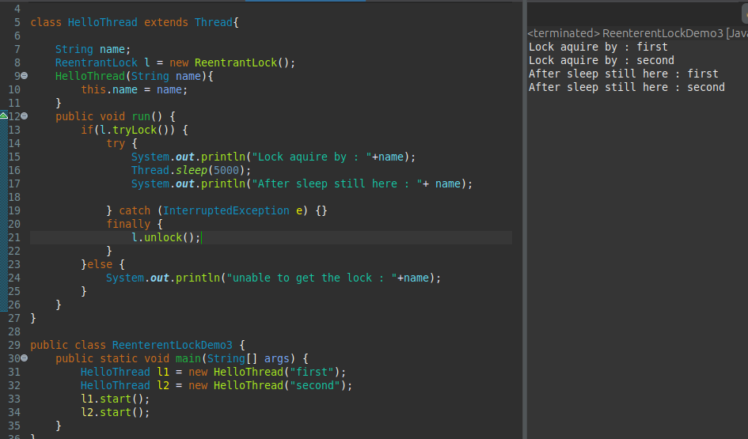

use fo tryLock(...timeunit)

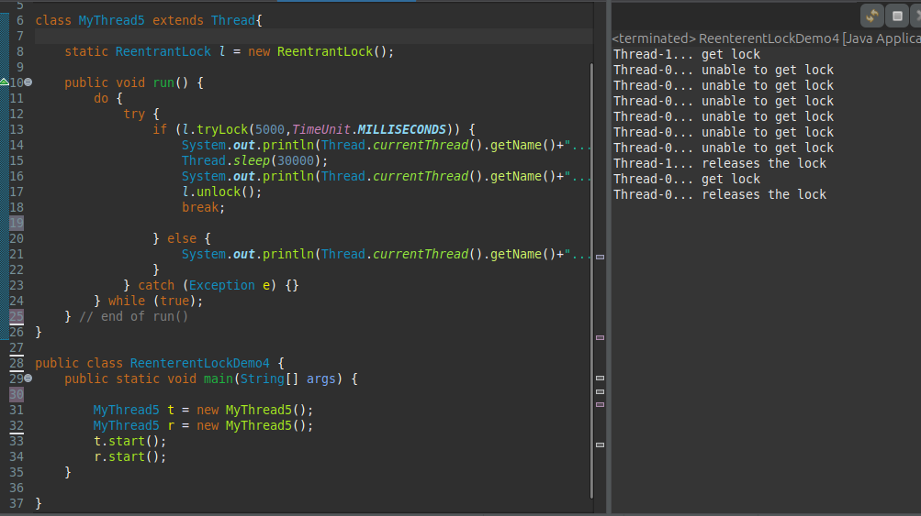

Video 18 :- Thread Pools ( Executor Framework)

# Thread pool ( Executor Framework ):- Creating a new Thread for every job may create performance or memory problems to over come this we should go Thread pool.
Thread pool is pool of already created for threads ready to do our job.
Java 1.5 version introduces Thread pool framework to implement Thread pools.
Thread pool framwork also known as Executor framework.

# How we can create Thread pool?
We can create Thread pool as follows:
ExecutorService service = Executors.newFixedThreadPool(300);

we can submit a Runnable job by using submit method.
service.submit(job);

We can shutdown executor service by using shutdown() method.
service.shutdown();

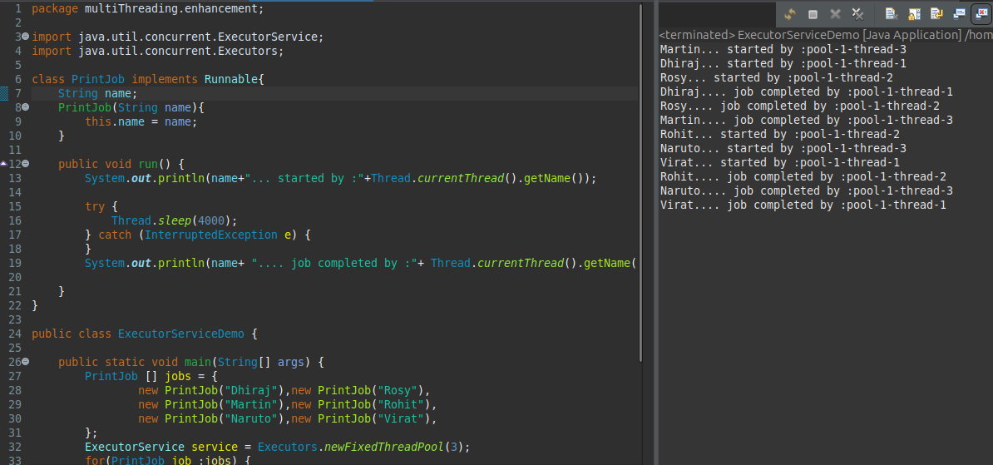

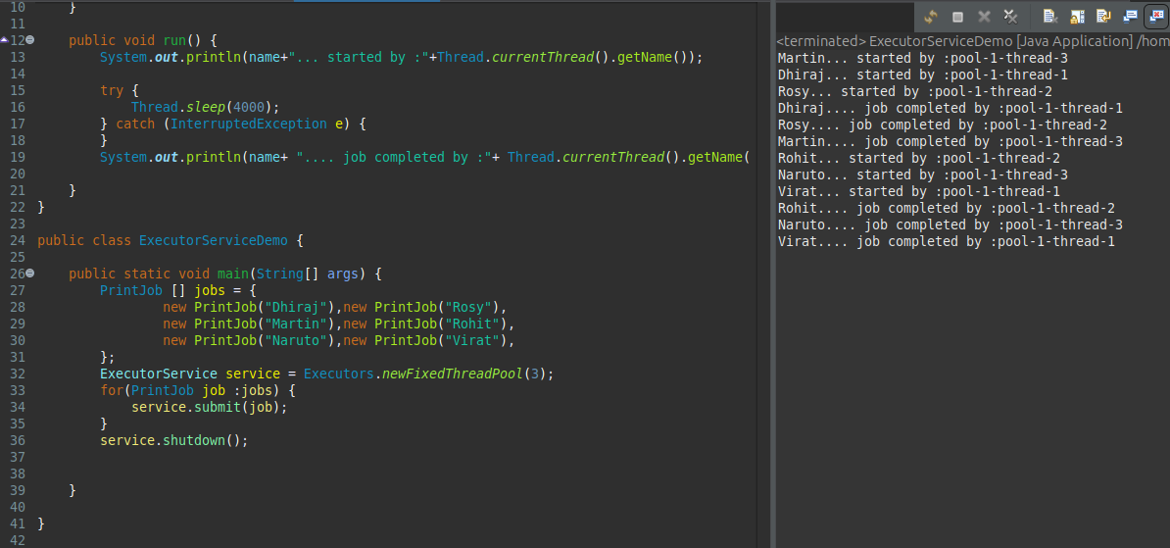

In the above example 3 Threads are responsible to execute 6 jobs , So that a single thread can be resued for multiple job.
Note :- While designing web servers and application servers we can use Thread Pool concept. (default 60 threads)

# Callable and Future :- In the case of Runnable job Thread won’t return anything after completing the job.
If a Thread is required some result after execution then we should go for callable.
Callable interface method contains only one method call()
public Object call() Throws Exception
If submit callable object to executor then after completing the job thread returns an object of the type Future i.e Future object can be used to retrive the result from callable job.

# Constructor :-
TheadLocal tl = new ThreadLocal();
Creates a ThreadLocal variable

Methods :-
- Object get() :- Returns the value of ThreadLocal variable associated with current Thread.
- Object initialValue() :- I
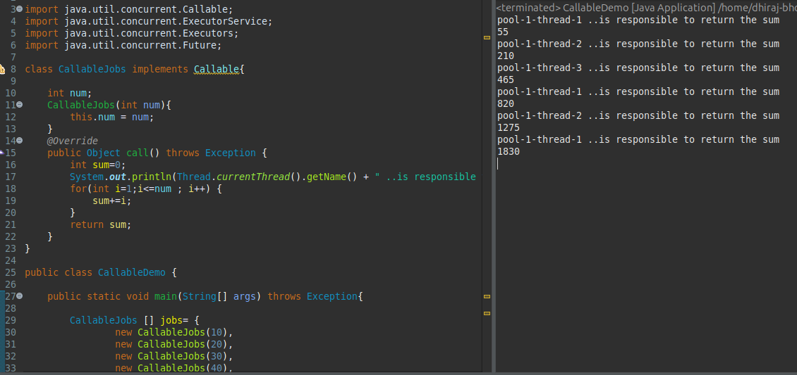

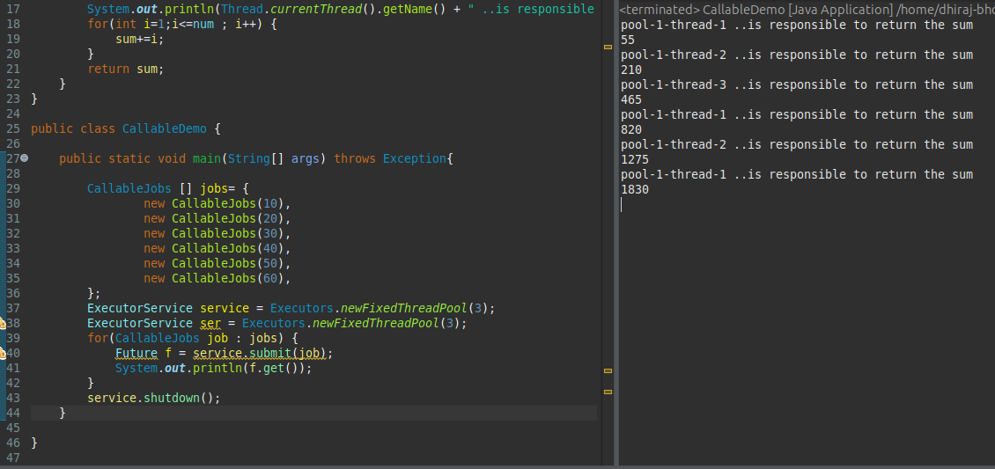

Runnable | Callable
if Thread is not required to return anything after completing the job then we should go for Runnable. | If a Thread a required to return something after completing the job then we should go for Callable.
Runnable contains only one method run(). | Callable interface contains only one method call().
Runnable job not required to return anything and hence return type of run() method is void. | Callable job is required to return something and hence return type of call method is Object.
Within the run() if there is any chance of rising Checked Exception compulsory we should handle by using try-catch because we can’t use throws method for run(). | Within call() if there is any chance of rising Checked Exception we are not required to handle using try-catch because call() already throws exception.
Runnable Interface present in java.lang package. | Callable interface present in java.util.concurrent package.
introduced in java 1.0 v | introduced in 1.5 v

Video 19 :- Thread Local

Thread local :- ThreadLocal class provides Thead local varaibles, ThreadLocal class maintains values per Thread bases.
Each ThreadLocal object maintains a seperate value like userId, transaction id,..etc for each Thread that access that object.
Thread can access Its local value can manipulate its value and even can remove its value.
In every part of the code which is executed by the Thread we can access its local variable.
Ex. Consider a servlet which envokes some bussiness methods we have a requirement to generate a unique transaction id for each and every request and we have to pass this transaction id to the bussiness methods for this requiement we can use the Thread local to maintain a seperate transaction id for every request i.e for every Thread.
Note:-
  - ThreadLocal class introduced in 1.2 version and Enhanced in 1.5 version.
  - Thread local can be associated with Thread scope.
  - Total code which is executed by the Thread has access to corresponding local variables.
  - A Thread can access its own local variables and can’t access other Threads local variables.
  - Once Thread entered into dead state all its local variables are by default eligible for garbage collection.

Constructor :-
ThreadLocal tl = new ThreadLocal();

Methods :-
- Object get() :- Returns the value of ThreadLocal variable associated with current Thread.
- Object initialValue() :- Returns the initial value of ThreadLocal variable associated with current Thread. The Defult implimentation of this method returns null.
To customise our own initial value we have to override this method.
- void set(Object newValue) :- To set a new value.
- void remove() :- To remove the value of ThreadLocal to associated with current Thread. It is newly added method in 1.5 version. After removal if we are try to access it will be reiniitialize again by invoking its initial method.

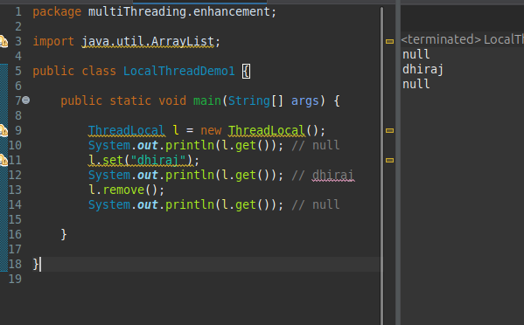

# Overriding of initialValue() method.

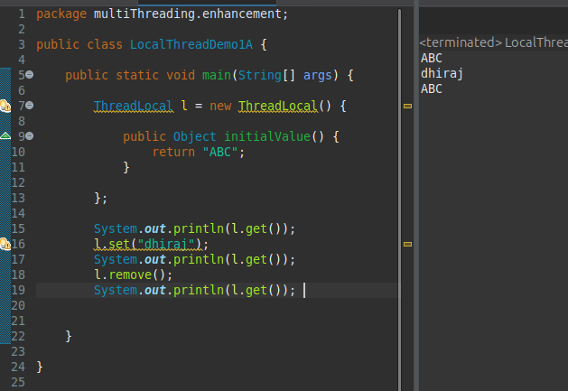

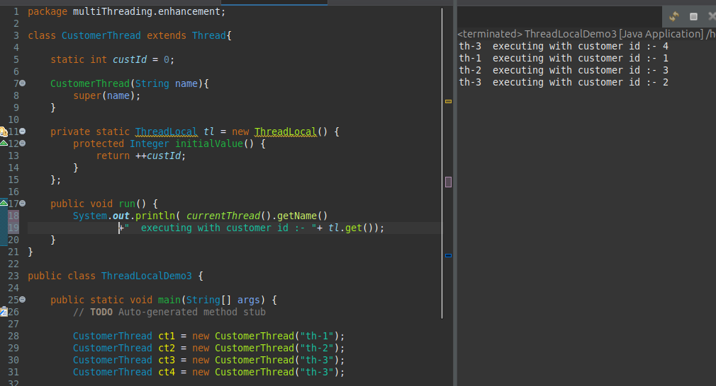

- In above program for every customer Thread a seperate customer id will be maintained by ThreadLocal object.

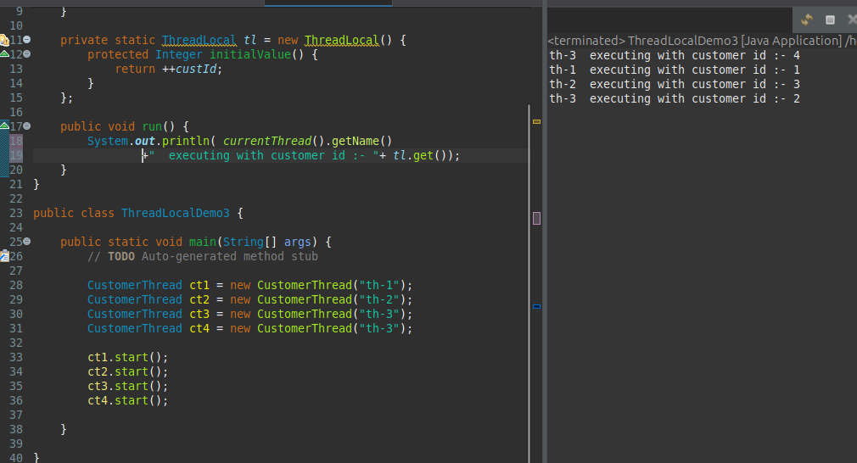

50:00 start

